CONTENT OF TABLE
S.NO | CONTENT | PAGE NO
1. | INTRODUCTION | 1
2. | COMPONENTS LIST AND DESCRIPTION | 2
3. | CIRCUIT DIGRAM | 5
4. | CODE AND EXPLANATION | 6
5. | WORKING PRINCIPLE | 7
6. | ADVANTAGES | 9
7. | CONCLUSION AND FUTURE WORK | 12
8. | SCREENSHOT | 13
9. | REFERENCE | 14

ORBIT-X: Autonomous Satellite Monitoring & AI Command Console
ABSTRACT
ORBIT-X is an autonomous satellite monitoring and AI-driven command console developed for the TITAN-1 mission, designed to integrate real-time IoT telemetry with advanced edge-based intelligence. The system addresses key limitations of conventional monitoring architectures—such as high latency, cloud dependency, and lack of predictive capabilities—by implementing a hybrid edge-cloud framework.
At the hardware level, an ESP32-based AgriNode collects multi-dimensional environmental and inertial data through a network of sensors. This telemetry is transmitted to a ground-based control system, where a Node.js orchestration layer standardizes and processes the data in real time. A dedicated Python-based Neural Core performs intelligent analysis using a combination of machine learning models, including Autoencoders for anomaly detection and LSTM networks for time-series forecasting.
The system operates on a continuous sense–analyze–act loop, enabling proactive identification of system irregularities and prediction of future states such as battery degradation and environmental changes. Data is locally persisted using a lightweight database to ensure offline functionality, while periodic synchronization with the cloud via MQTT allows for global monitoring and model updates.
Key features of ORBIT-X include low-latency processing (<50 ms), autonomous fault handling through simulation and fallback mechanisms, adaptive data logging strategies, and scalable architecture for distributed node monitoring. The platform demonstrates that satellite-grade monitoring and predictive intelligence can be achieved using cost-effective hardware and modern software technologies.
ORBIT-X establishes a foundation for future advancements in autonomous systems, including digital twin visualization, decentralized learning, and long-range communication integration, making it applicable across domains such as aerospace, precision agriculture, and industrial IoT.

1.INTRODUCTION:
ORBIT-X is an advanced autonomous satellite monitoring and control system engineered for the TITAN-1 mission, designed to seamlessly integrate IoT-based telemetry acquisition with AI-driven predictive analytics.
Modern satellite and remote sensing systems often suffer from high latency, excessive cloud dependency, and limited fault tolerance. ORBIT-X addresses these challenges through a hybrid edge-cloud architecture, where critical computations are executed locally while the cloud is utilized for synchronization and global intelligence.
The system is built upon three foundational principles:
- Autonomous Intelligence: Real-time anomaly detection and predictive decision-making using machine learning models.
- Edge Resilience: Continuous operation independent of internet connectivity.
- Scalable Monitoring: Capability to monitor multiple distributed nodes (AgriNodes) globally.
Primary Objectives:
- High-fidelity real-time telemetry acquisition (15+ parameters)
- Autonomous anomaly detection using AI models
- Predictive analytics for system stability and resource optimization
- Seamless integration with cloud platforms for global synchronization

2.COMPONENTS LIST AND DISCRIPTION
Hardware Components
- ESP32 Microcontroller
- MPU6050 (IMU Sensor)
- Soil Moisture Sensor
- DHT11 Sensor
- Ultrasonic Sensor (HC-SR04)
- LDR (Light Dependent Resistor)

ESP32 Microcontroller
The ESP32 is the central controller of the AgriNode system, featuring a dual-core processor with built-in Wi-Fi and Bluetooth for efficient communication. It collects sensor data, processes it in real time, transmits it to servers, and executes control actions such as irrigation.
MPU6050 (IMU Sensor)
The MPU6050 is an inertial measurement unit that combines a 3-axis accelerometer and a 3-axis gyroscope to detect motion and orientation. It is used for applications like tilt monitoring, motion detection, and identifying environmental disturbances.
Soil Moisture Sensor
The soil moisture sensor measures the water content in soil by analyzing electrical resistance between its probes. It enables smart irrigation by ensuring optimal water levels and preventing overwatering or drought conditions.
DHT11 Sensor
The DHT11 sensor measures ambient temperature and relative humidity in the environment. It supports climate monitoring and helps in analyzing crop health conditions effectively.
Ultrasonic Sensor (HC-SR04)
The HC-SR04 ultrasonic sensor measures distance by emitting sound waves and calculating the time taken for the echo to return. It is commonly used for water level monitoring and obstacle detection in smart systems.
LDR (Light Dependent Resistor)
The LDR detects light intensity by changing its resistance based on the amount of light falling on it. It is useful for solar optimization, automatic lighting control, and day/night detection systems.

Software Components
- Electron (Core Dashboard)
- Node.js (System Orchestrator)
- Python (Neural Core – AI Engine)
- TensorFlow.js & PyTorch
- MS Access (MDB Database)
- MQTT (ThingsBoard Integration)
Electron (Core Dashboard)
Electron is used to develop the ORBIT-X Command Console, a cross-platform desktop application with a rich graphical interface. It enables real-time telemetry visualization through graphs, gauges, and alerts, along with dynamic and interactive dashboards. It also supports offline monitoring and seamless integration of frontend technologies with backend logic.
Node.js (System Orchestrator)
Node.js acts as the central control layer that coordinates communication between all system components efficiently. It manages IPC, reads sensor data from ESP32, handles database operations, and connects with Python AI services and MQTT. Its non-blocking, event-driven architecture makes it highly suitable for real-time IoT systems.
Python (Neural Core – AI Engine)
Python serves as the intelligence layer using a Flask-based microservice for AI processing and decision-making. It hosts LSTM models for time-series forecasting and autoencoders for anomaly detection in sensor data. The system exposes REST APIs to receive inputs from Node.js and return predictions and alerts.
TensorFlow.js & PyTorch
TensorFlow.js and PyTorch are used for building, training, and deploying machine learning models across the system. TensorFlow.js enables lightweight AI execution directly in the browser, supporting edge-level predictions. PyTorch is used for deep learning model training and backend inference, enabling hybrid AI deployment.
MS Access (MDB Database)
MS Access is a lightweight, file-based database used for storing and managing local telemetry data efficiently. It maintains logs, historical records, and ensures data availability even in offline conditions. Its simplicity and fast local access make it ideal for small-scale IoT storage solutions.
MQTT (ThingsBoard Integration)
MQTT is a lightweight messaging protocol used for real-time communication and cloud integration in IoT systems. It enables efficient publish/subscribe data transmission with low bandwidth consumption and high reliability. The system uses MQTT to send telemetry data, receive remote commands, and synchronize AI models.

System Layers
Data Acquisition Layer
Handles serial communication via Node.js with high-speed transfer at 115200 baud. Ensures fast and reliable collection of sensor data from hardware modules.
Data Normalization Layer
Uses regex-based parsing to process incoming raw sensor data efficiently. Converts heterogeneous inputs into standardized JSON vectors for further processing.
AI Processing Layer
Sends normalized data to the Python Neural Core for intelligent analysis. Uses Autoencoders for anomaly detection and LSTM models for predictive forecasting.
Persistence Layer
Stores processed data in MDB using batched operations for efficiency. Optimizes write cycles to minimize I/O overhead and improve performance.
Visualization Layer
Implements an Electron-based interface for system monitoring. Displays real-time telemetry through interactive graphs and dashboards.
Cloud Integration Layer
Utilizes MQTT protocol with ThingsBoard for seamless cloud communication. Enables periodic data synchronization and supports remote monitoring and updates.

3.Circuit diagram

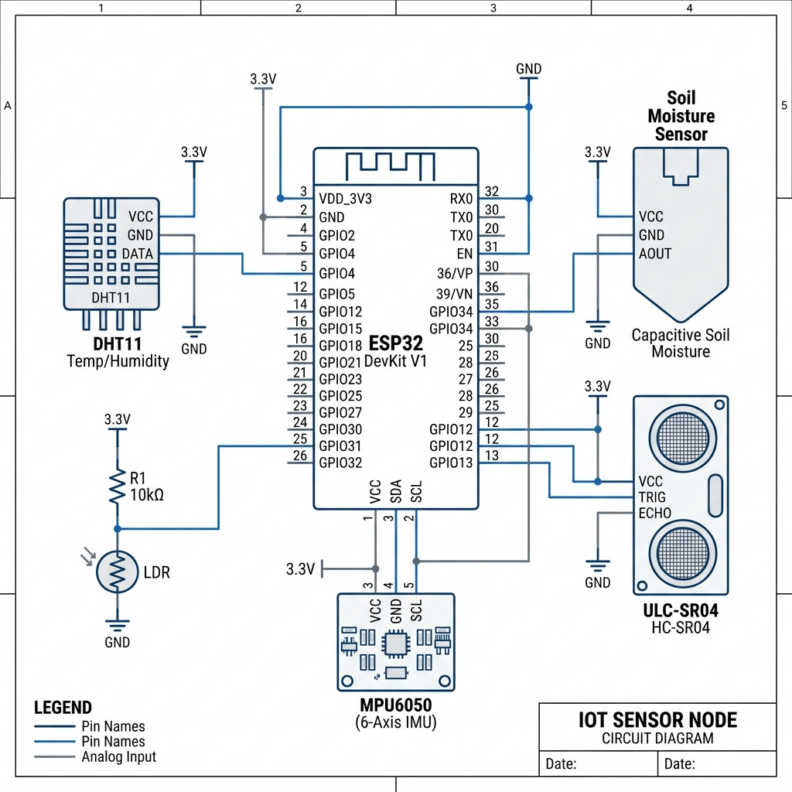

4.Code and Explanation:

5.WORKING PRINCIPLE
🔄 Sense → Analyze → Act Cycle
Step 1: Data Acquisition
The ESP32 continuously gathers real-time telemetry from multiple sensors embedded in the environment. This data is transmitted rapidly to the system via serial communication for further processing.
Step 2: Data Standardization
Node.js processes incoming raw data using intelligent parsing mechanisms. It converts inconsistent sensor inputs into a clean, structured 15-feature telemetry vector for uniform analysis.
Step 3: Local Decision Logic
The system performs instant rule-based checks on incoming data streams. It triggers alerts and executes local actions, such as activating irrigation when soil moisture drops below a threshold.
Step 4: AI-Based Analysis
The processed data is sent to the Python Neural Core for advanced intelligence. Autoencoders detect anomalies through reconstruction error, while LSTM models forecast future conditions for proactive control.
Step 5: Data Persistence
Sensor and analysis data are stored locally in optimized batches. This reduces CPU load and minimizes disk I/O, ensuring efficient system performance.
Step 6: Cloud Synchronization
The system periodically uploads telemetry data to the cloud platform via MQTT. It also retrieves updated AI model parameters to maintain accuracy and adaptability.
Step 7: Fault Handling & Resilience
In case of hardware failure, a simulation mode ensures uninterrupted system operation. GPU Defense Mode maintains computational stability and protects the system from critical breakdowns.

5. ADVANTAGES
⚡ Uninterrupted Intelligence (Offline Capability)
The system operates independently of internet connectivity, ensuring continuous monitoring and control even in remote or network-limited environments. This guarantees zero downtime and reliable field performance.
🚀 Lightning-Fast Response (Low Latency)
With response times under 50 milliseconds, the system reacts almost instantly to changing conditions. This ultra-low latency enables real-time decision-making for critical operations like irrigation control.
🌐 Limitless Expansion (Scalability)
Designed with a modular architecture, the system can seamlessly scale to support multiple distributed nodes. It adapts effortlessly from small farms to large-scale smart agriculture deployments.
🛡️ Resilient by Design (Fault Tolerance)
Advanced fault-handling mechanisms ensure the system remains stable during hardware or software failures. Built-in recovery strategies and simulation modes maintain uninterrupted functionality.
🧠 Dual-Layer Intelligence (Hybrid AI)
By combining rule-based logic with machine learning models, the system achieves both instant reactions and predictive insights. This hybrid approach enhances accuracy, adaptability, and smart decision-making.
⚙️ Smart Efficiency (Resource Optimization)
Adaptive throttling dynamically adjusts system operations based on workload conditions. This minimizes CPU usage, reduces power consumption, and ensures optimal performance at all times.

6.SCREENSHOT
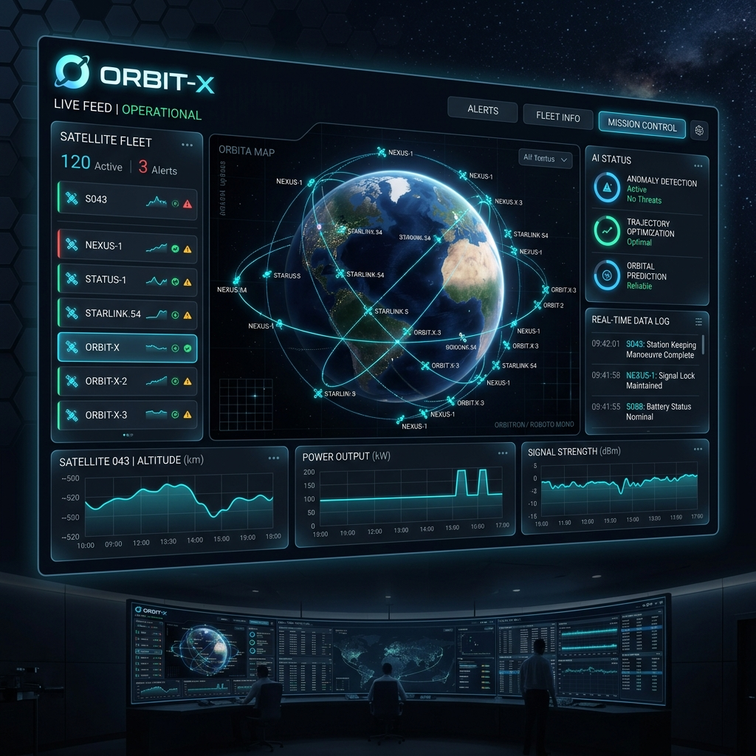

7. CONCLUSION
ORBIT-X establishes a forward-looking framework for autonomous monitoring by tightly integrating IoT hardware, edge computing, and artificial intelligence into a cohesive, production-ready platform. The architecture validates that robust, real-time operations are achievable without expensive infrastructure.
The system demonstrates that cost-effective hardware can deliver high-reliability monitoring, while edge-based AI reduces latency and enhances system resilience under variable conditions. The hybrid design—combining local intelligence with cloud synchronization—ensures an optimal balance between performance, scalability, and adaptability.
Beyond its initial scope, ORBIT-X is readily applicable to domains such as precision agriculture, industrial automation, and environmental monitoring, positioning it as a versatile solution for next-generation intelligent systems.

8. REFERENCES
- Electron Documentation – https://www.electronjs.org/docs
- SerialPort – https://serialport.io/
- ThingsBoard – https://thingsboard.io/
- TensorFlow – https://www.tensorflow.org/
- Mission TITAN-1 Technical Specification (Internal Document)

